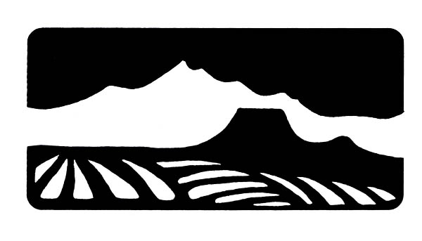

Dubois-Crowheart Conservation District
712 Meckem PO Box 27 Dubois, WY 82513
307-455-3688 dccd@dteworld.com

Cost Share Program Application: Food Security Solutions

An Equal Opportunity Program
We do not discriminate on the basis of race, color, religion, national origin, gender, age, disability, marital or veteran status, or any other legally protected status. No question on this application is used for the purpose of limiting or excluding any applicant from consideration prohibited by local, state or federal law.

Objective:
The Dubois-Crowheart Conservation District (DCCD) offers cost share funding to District constituents. This application is solely for food security solutions, i.e – greenhouses, hoop houses.

Funding:
The amount of cost share available for a District approved project is a maximum of 50% cost share with a cap of $2,500.00. For example, if the total cost of an approved project is $3,000.00, the District may provide up to $1,500.00. If the total cost of an approved project is $10,000.00, the District may provide up to $2,500.00.

DCCD will determine the cost share for each project on a case-by-case basis. DCCD also reserves the right to adjust the final cost share payment based on the final project costs. The amount and/or percent of cost share funding awarded to any project will be based on the scope, longevity, and broad-based benefit to multiple natural resources and District constituents.

Application Process:

- Submit complete application between January 1 and April 30. Two project estimates/quotes are required for materials. DCCD will only cost share on the lowest estimate/quote.
- The Board will hold a hearing at its first meeting post-submission to decide if the project will be funded. You may be asked to attend a meeting if the Board requires more clarification of project goals or details. Meetings are every second Wednesday at 4:00 p.m. You will be notified of the Board’s decision at which point you may accept or decline the cost share. If you accept, move to Step 3.
- Order materials for your project; DCCD will only reimburse for new materials.
- Submit receipts and photos of completed project. Projects must be completed prior to October 1. Reimbursement cannot be made prior to July 1.
- Receive a check for the awarded amount, unless the final project total was for a lesser amount.
- DCCD reserves the right for a Board member or Manager to visit and photograph the project site.
- DCCD will furnish you with an IRS 1099 form for tax purposes.

Applicant Responsibilities (if applicable):
- Provide photo(s) of project area with application
- Provide proof of Landowner Concurrence if on lease property
- Comply with town building regulations
- Provide proof of water rights
- Provide proof of access to water source
- Provide copies of paid receipts prior to receiving reimbursement
- Provide photo(s) of completed project area prior to receiving reimbursement
- Group projects must verify membership support with application

The Dubois-Crowheart Conservation District, a member of the Wyoming Association of Conservation Districts, provides leadership for the conservation of Wyoming’s soil and water, to promote the control of soil erosion, to promote and protect the quality of Wyoming’s waters, reduce the siltation of stream channels and reservoirs, promote wise use of Wyoming’s water, and all other natural resources, preserve and enhance wildlife habitat, protect the tax base and promote the health, safety and general welfare of the citizens of this state through a responsible conservation ethic.

Name:
Name used on application will be used on reimbursement payments and IRS 1099 forms.
Mailing Address:
Physical Address (if different):
Phone Number:
Email address:

Project Information

Project Description/Overview: (use drawings if needed)

Project Location: (GPS coordinates, physical address, attach map, or give detailed description of location)

Plan of Work: (anticipated schedule for beginning, development and completion)

Project Significance: (expectations for improving quality and/or use of natural resources)

Itemized Expenses: (2 estimates/quotes for materials)
Item:  (part description) | Number:  (total pieces) | Cost:  (per piece) | Total:
 |  | Total:

TWO OR MORE ESTIMATES OR QUOTES MUST BE ATTACHED
ATTACH ADDITIONAL PAGES IF NECESSARY

DCCD shall not be held liable for any personal or property damage incurred while implementing the conservation practices described in this agreement.

By signing, you agree to the following checklist:

_______ Provide before and after photos of the project area

_______ Provide proof of water rights, if necessary and applicable

_______ Show proof of access to water source, if necessary and applicable

_______ Provide two or more quotes

_______ Provide Landowner concurrence if practice will be on lease property

_______ Verify member support, if a group project

_______ Provide paid receipts of expenses incurred

I understand that payment is contingent upon completion of all items on this checklist.

Signature ____________________________________________

Date ____________________________________________

